$ cd /home/inferyx/git/

~/git/application2/intrigue2$ ls

inferyx@ip-172-26-13-27:~/git/application2/intrigue2$ cd src/

inferyx@ip-172-26-13-27:~/git/application2/intrigue2/src$ ls

inferyx@ip-172-26-13-27:~/git/application2/intrigue2/src$ cd app/

inferyx@ip-172-26-13-27:~/git/application2/intrigue2/src/app$ ls

app-config.service.ts

change company name website here

inferyx@ip-172-26-13-27:-/git/application2/intrigue2/src/app$ nano app-config.service.ts

inferyx@ip-172-26-13-27:~/git/application2/intrigue2/src/app$ source ~/.bashrc

inferyx@ip-172-26-13-27:~/git/application2/intrigue2/src/app$ cd ../..

inferyx@ip-172-26-13-27:~/git/application2/intrigue2$ nvm use 20

Now using node v20.12.0 (npm v10.5.0)

inferyx@ip-172-26-13-27:~/git/application2/intrigue2$ ng build --base-href=/clearrinsights/ --c production

✓ Browser application bundle generation complete.

✓ Copying assets complete.  
======================|

inferyx@ip-172-26-13-27:/opt$ cd /home/inferyx/git/application2/intrigue2/

inferyx@ip-172-26-13-27:~/git/application2/intrigue2$ ls

CHANGELOG.md LICENSE.md README.md angular.json dist

inferyx@ip-172-26-13-27:~/git/application2/intrigue2$ cd dist/

inferyx@ip-172-26-13-27:~/git/application2/intrigue2/dist$ ls

intrigue2

inferyx@ip-172-26-13-27:~/git/application2/intrigue2/dist$ cd intrigue2/

inferyx@ip-172-26-13-27:~/git/application2/intrigue2/dist/intrigue2$ ls

1221.a9f9e7b4176912df.js  
=========================

inferyx@ip-172-26-13-27:~/git/application2/intrigue2/dist$ mv intrigue2 clearrinsights

inferyx@ip-172-26-13-27:~/git/application2/intrigue2/dist$ ls

clearrinsights

inferyx@ip-172-26-13-27:~/git/application2/intrigue2/dist$ cp -R clearrinsights /opt/tomcat/webapps/

inferyx@ip-172-26-13-27:~/git/application2/intrigue2/dist$ cd /opt/tomcat/webapps/

inferyx@ip-172-26-13-27:/opt/tomcat/webapps$ cp clearrinsights2/assets/layout/images/logo-dark.png framework/app/img/

inferyx@ip-172-26-13-27:/opt/tomcat/webapps$ cd framework/app/img/

inferyx@ip-172-26-13-27:/opt/tomcat/webapps/framework/app/img$ mv logo-dark.png logo-black.png

inferyx@ip-172-26-13-27:/opt/tomcat/webapps/framework/app/img$ cp logo-black.png logo-white.png

inferyx@ip-172-26-13-27:/opt/tomcat/webapps/framework/app/img$ cd ..

inferyx@ip-172-26-13-27:/opt/tomcat/webapps/framework/app$ cd js/

inferyx@ip-172-26-13-27:/opt/tomcat/webapps/framework/app/js$ cd config/

inferyx@ip-172-26-13-27:/opt/tomcat/webapps/framework/app/js/config$ ls  
config.js  
inferyx@ip-172-26-13-27:/opt/tomcat/webapps/framework/app/js/config$ nano config.js

inferyx@ip-172-26-13-27:/opt/tomcat/webapps/framework/app/js/config$  
  
"companyName":"Grant Thornton",

"websitLink": "https://www.grantthornton.in",

"companyLog": null,

"browserTabTitle":"Grant Thornton",

and check on this website

<http://65.1.212.204:8080/framework/app/index.html#!/dashboard>  
  
  
  
=============================================================  
and for changing inside logo

501  cd /opt/tomcat/webapps/  
  502  cp clearrinsights2/assets/layout/images/logo-dark.png clearrinsights/assets/layout/images/  
  503  cd clearrinsights  
  504  ls  
  505  nano index.html

(<!doctype html>

<html lang="en" data-critters-container>

<head>

<title>Grant Thornton</title>

<base href="/clearrinsights/">

<link rel="icon" type="image/x-icon" href="favicon.ico">

<style>:root{font-family:"Inter var", sans-serif;font-feature-settings:"cv02", "cv03", "cv04", "cv11";font-variation-settings:normal;--font-family:"Inter var", sans-serif;--font-feature-settings:">

<!--Meta -->

<meta charset="utf-8">

<meta name="viewport" content="width=device-width, initial-scale=1">)

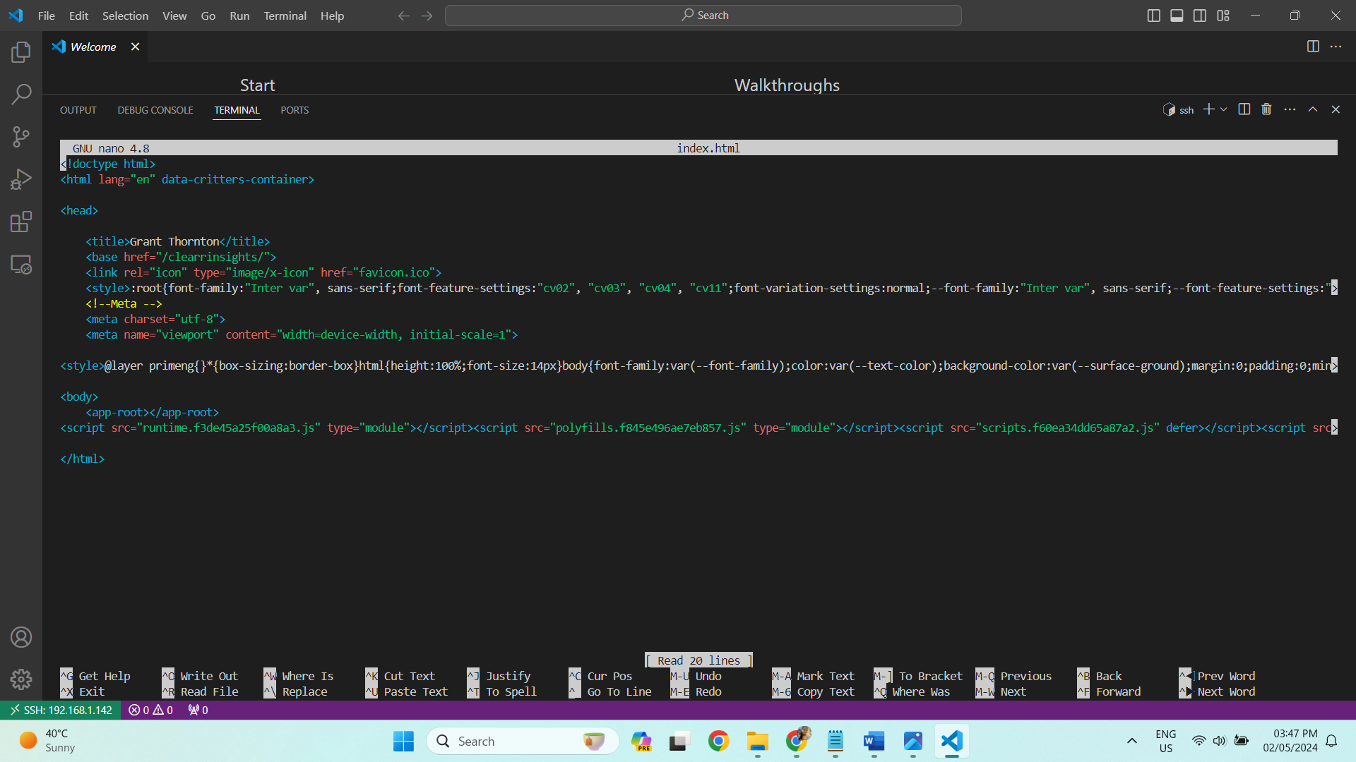  
  506  history

Images

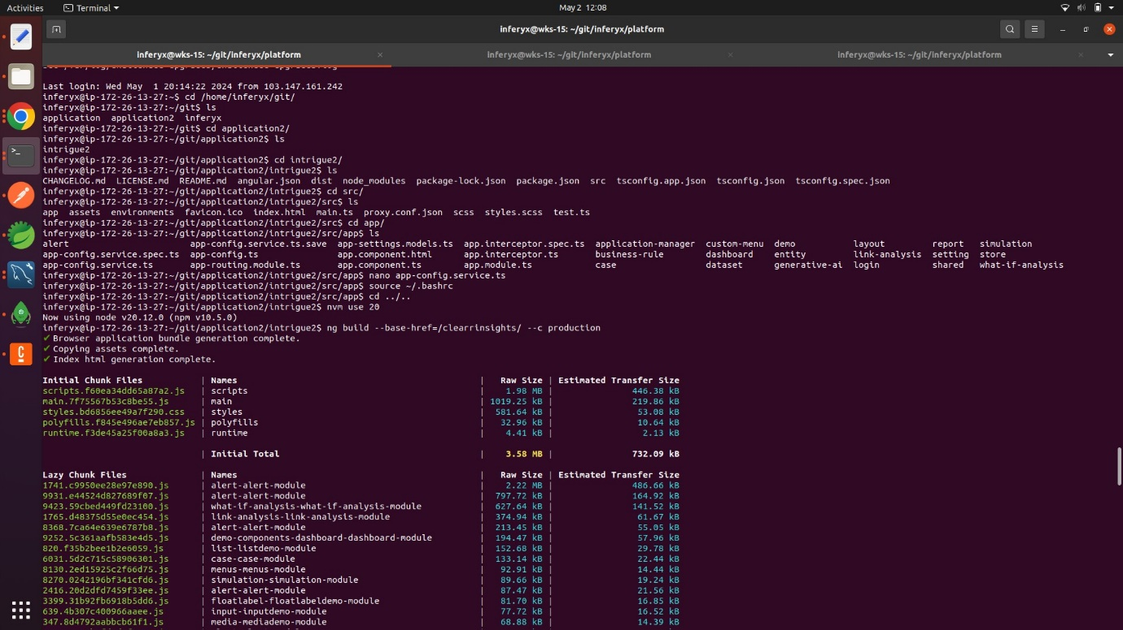

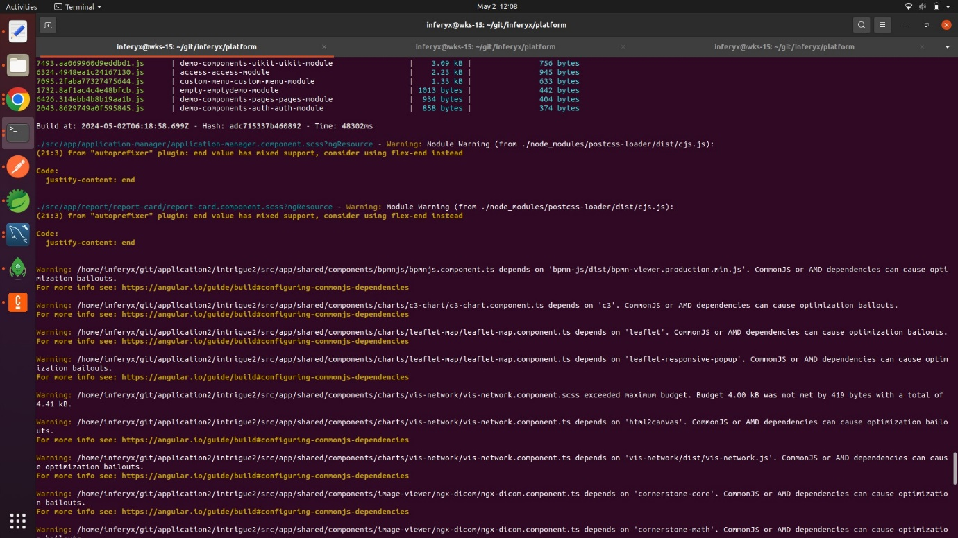

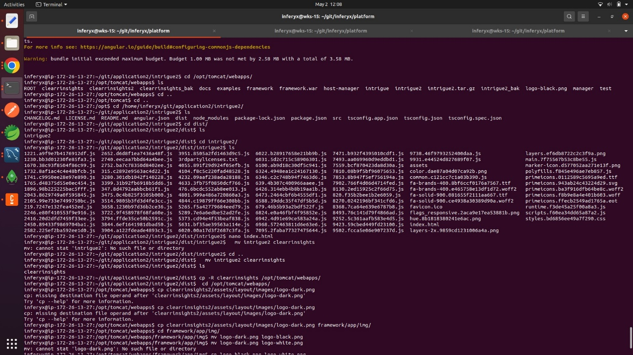

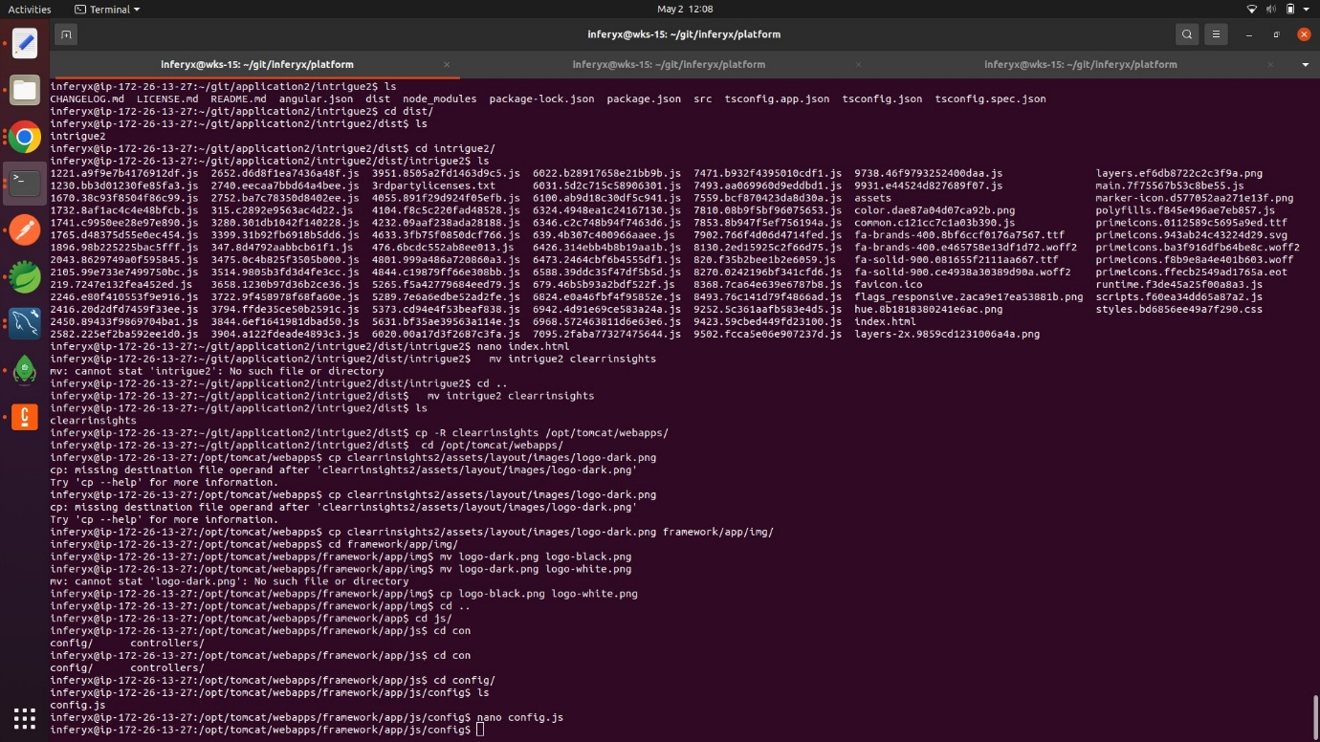  
  
  
==========================

For changing inside logo   
